Uczelnie techniczne
Bulgaria
Technical University of Varna / www.tu-varna.bg
Erasmus code: BG VARNA02/ Country: Bulgaria
Subject area code: 0710
Subject area name: Engineering, manufacturing and construction n.f.d.
Study cycle: 1st, 2nd
Number of students / mobility period: 3*5
Number of staff / mobility period: 3/5 days STA
University of Food Technologies Plovdiv (UFT) / uft-plovdiv.bg
Erasmus code: BG PLOVDIV05 / Country: Bulgaria
Subject area code: 0721
Subject area name: Food processing
Study cycle: 1st,
Number of students / mobility period: 2*5
Number of staff / mobility period: 2/5 days STA
Czechia
Technická Univerzita V Liberci / www.tul.cz
Erasmus code: CZ LIBEREC01/ Country: Czechia
Subject area code: 071
Subject area name: Building and civil engineering
Study cycle: 1st,2nd, 3rd
Number of students / mobility period: 2*5
Number of staff / mobility period: 1/5 days STA, 1/5days STT
Vysokeé učeni technické v Brně / www.vut.cz
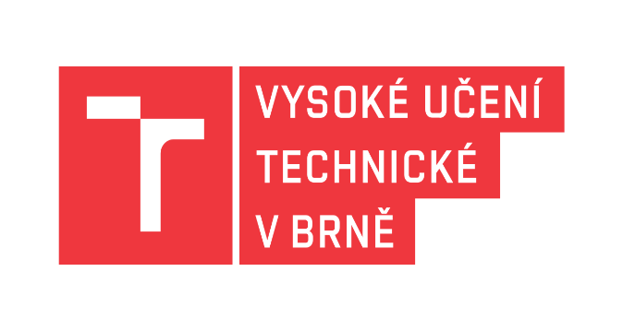
Erasmus code: CZ BRNO01/ Country: Czechia
Subject area code: 0732
Subject area name: Building and civil engineering
Study cycle: 1st,2nd, 3rd
Number of students / mobility period: 2*5
Number of staff / mobility period: 3/5 days STA, 1/5days STT

ZAPADOCESKA UNIVERZITA V PLZNI / www.zcu.cz/cs/index.html
Erasmus code CZ PLZEN01/

Subject area code: 07, 06
Subject area name: Engineering and engineering trades, Information and Communiactaion Technologies (computer science)
Study cycle: 1st,2nd, 3rd
Number of students / mobility period: 2*5
Number of staff / mobility period: 2/5 days STA
Univerzita Jana Evangelisty Purkyne v Usti nad Labem
www.ujep.cz/en
Erasmus code CZ USTINAD01
Subject area code: 07, 003
Subject area name: Engineering and engineering trades, Personal skills and evelopment
Study cycle: 1st,2nd, 3rd
Number of students / mobility period: 2*5
Number of staff / mobility period: 2/5 days STA, 2+5 days STT

VSB Technical University Ostrava / www.vsb.cz/en
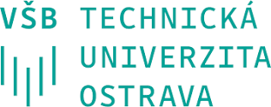
Erasmus code CZ OSTRAVA01/
Subject area code: 07, 04, 03
Subject area name: Engineering and engineering trades, Building and civil engineering, Econom,ics and Business and administration
Study cycle: 1st, 2nd, 3rd
Number of students / mobility period: 2*5
Number of staff / mobility period: 2/5 days STA
Institute of Technology and Business in Ceske Budejovice
www.vstecb.cz
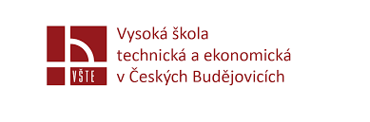
Erasmus code CZ OSTRAVA01CZ CESKE04
Subject area code: 07,
Subject area name: Engineering and engineering trades,
Study cycle: 1st, 2nd, 3rd
Number of students / mobility period: 2*5
Number of staff / mobility period: 1/5 days STA, 1/5 days STT

Finland
Oulu University of Applied Sciences / www.oamk.fi/en

Erasmus code: SF OULU11
Subject area code: 07
Subject area name: Engineering
Study cycle: 1st, 2nd
Number of students / mobility period: 2*5
Number of staff / mobility period: 2/5 days STA
Seinajoki University of Applied Science / www.seamk.fi/en
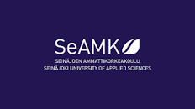
Erasmus code: SF OULU11
Subject area code: 06, 07
Subject area name: Engineering, Information and Communication Technologies
Study cycle: 1st
Number of students / mobility period: 2*5
Number of staff / mobility period: 2/5 days STA
SAVONIA University of Applied Science / www.savonia.fi/en/homepage
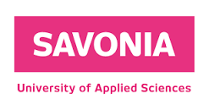
Erasmus code: SF KUOPIO08
Subject area code: 07, 06
Subject area name: Engineering, Information and Communication Technologies
Study cycle: 1st
Number of students / mobility period: 2*5
Number of staff / mobility period: 2/5 days STA
France
Universite de Poitiers / www.univ-poitiers.fr/en
Erasmus code: F POITIERS01
Subject area code: 07,
Subject area name: Engineering,
Study cycle: 1st
Number of students / mobility period: 2*5
Number of staff / mobility period: 2/5 days STA
INSA Centre Val de Loire / insa-centrevaldeloire.fr/en
Erasmus code: F BLOIS13
Subject area code: 07, 06
Subject area name: Engineering, Communication and Information Technologies
Study cycle: 1st, 2nd, 3rd
Number of students / mobility period: 4*5
Number of staff / mobility period: 2/5 days STA
Germany
Hochschule Wismar / www.hs-wismar.de
Erasmus code: D WISMAR01
Subject area code: 07, 732
Subject area name: Engineering, Building and civil engineering
Study cycle: 1st, 2nd
Number of students / mobility period: 2*5
Number of staff / mobility period: 2/5 days STA
Technische Universität Darmstadt / www.tu-darmstadt.de
Erasmus code: D DARMSTA01
Subject area code: 07
Subject area name: Engineering
Study cycle: 1st
Number of students / mobility period: 2*5
Number of staff / mobility period: 2/5 days STA
Fachhochschule Düsseldorf / hs-duesseldorf.de
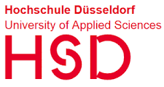
Erasmus code: D DUSSELD03
Subject area code: 071
Subject area name: Engineering and engineering trades
Study cycle: 1st
Number of students / mobility period: 2*5
Number of staff / mobility period: 2/5 days STA
Hochschule Neubrandenburg / www.hs-nb.de
Erasmus code: D NEUBRAN02
Subject area code: 07, 532, 81
Subject area name: Engineering and engineering trades, Earth Sciences, Geodesy, geoinformatics, Food Processing
Study cycle: 1st, 2nd
Number of students / mobility period: 2*5, 2*5, 2*5
Number of staff / mobility period: 2/5 days STA, 2/5 days STA, 2/5 days STA
University of Rostock / www.uni-rostock.de
Erasmus code: D ROSTOCK01
Subject area code: 071
Subject area name: Engineering and engineering trades, (Mechatronics , Biomedical Engineering)
Study cycle: 1st, 2nd
Number of students / mobility period: 2*5
Number of staff / mobility period: 1/5 days STA
Technische Universität Braunschweig / www.tu-braunschweig.de
Erasmus code: D BRAUSC01
Subject area code: 07, 081
Subject area name: Engineering and engineering trades, Food Processing
Study cycle: 1st, 2nd
Number of students / mobility period: NA
Number of staff / mobility period: 1/5 days STA/STT
Greece
Technological Educational institute (T.E.I) of Athens
www.teiath.gr/categories.php?mid=4&lang=en
Erasmus code: G ATHINE34
Subject area code: 712, 532
Subject area name: Environmental Protection Technology, Earth Sciences
Study cycle: 1st, 2nd
Number of students / mobility period: 4*5
Number of staff / mobility period: 2/5 days STA, 2/5 STT
Hungary
Neumann János Egyetem / nje.hu
Erasmus code: HU KECSKEM03
Subject area code: 06, 071
Subject area name: Communication and Information Technologies, Engineering
Study cycle: 1st
Number of students / mobility period: 2*5, 2*5
Number of staff / mobility period: 2/5 days STA, 2/5 days STA
Italy
Universita degli studi di Firenze / www.unifi.it
Erasmus code: I FIRENZE01
Subject area code: 071
Subject area name: Engineering and engineering trades
Study cycle: 1st, 2nd
Number of students / mobility period: 1*5
Number of staff / mobility period: N/A
University of Palermo
www.unipa.it/target/international-students/en
Erasmus code: I PALERMO01
Subject area code: 0714
Subject area name: Electronics and automation
Study cycle: 1st, 2nd
Number of students / mobility period: 2*5
Number of staff / mobility period: 1/5 days STA
Politecnico di Milano / www.polimi.it/en
Erasmus code: I MILANO02
Subject area code: 732
Subject area name: Building and civil engineering
Study cycle: 1st, 2nd
Number of students / mobility period: 2*5
Number of staff / mobility period: 1/5 days STA
Latvia
Riga Technical University / www.rtu.lv/en
Erasmus code: LV RIGA02
Subject area code: 07
Subject area name: Engineering, manufacturing and construction
Study cycle: 1st, 2nd
Number of students / mobility period: 2*5
Number of staff / mobility period: 1/5 days STA
Latvia University of Life Sciences and Technologies / www.lbtu.lv/en
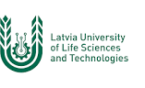
Erasmus code: LVJELGAVA01
Subject area code: 07
Subject area name: Engineering, manufacturing and construction
Study cycle: 1st, 2nd
Number of students / mobility period: 2*5
Number of staff / mobility period: 1/5 days STA
Lithuania
Vilnius Gediminas Technical University / vilniustech.lt/index.php?lang=2
Erasmus code: LT VILNIUS02
Subject area code: 0714, 732, 061
Subject area name: Electronics and automation ; Building and Civil Engineering; Communication and Information Technologies
Study cycle: 1st, 2nd
Number of students / mobility period: 2*5
Number of staff / mobility period: 1/5 days STA
Vilnius University / www.vu.lt
Erasmus code: LT VILNIUS01
Subject area code: 07
Subject area name: Engineering and engineering trades
Study cycle: 1st, 2nd
Number of students / mobility period: 2*5
Number of staff / mobility period: 1/5 days STA
Malta
Malta College of Arts, Science and Technology / mcast.edu.mt
Erasmus code: MT MALTA02
Subject area code: 07, 061
Subject area name: Engineering and engineering trades , Communication and Information Technologies
Study cycle: 1st
Number of students / mobility period: 3*5, 2*5
Number of staff / mobility period: 1/5 days STA, 1/5 days STA
Norway
Norwegian University of Science and Technology / www.ntnu.edu
Erasmus code: LT VILNIUS01
Subject area code: 07
Subject area name: Engineering and engineering trades
Study cycle: 1st
Number of students / mobility period: 2*5
Number of staff / mobility period: 1/5 days STA
Portugal
Polytechnic Institute of Bragança
portal3.ipb.pt/index.php/en/ipben/home
Erasmus code: P BRAGANC01
Subject area code: 07, 732
Subject area name: Engineering and engineering trades , Civil Engineering
Study cycle: 1st
Number of students / mobility period: 5*5
Number of staff / mobility period: 1/5 days STA, 1/5 days STA
Universidade Nova de Lisboa / www.unl.pt
Erasmus code: P LISBOA03
Subject area code: 732
Subject area name: Building and Civil Engineering
Study cycle: 1st, 2nd, 3rd
Number of students / mobility period: 3*5
Number of staff / mobility period: 1/5 days STA
Técnico Lisboa / tecnico.ulisboa.pt/en
Erasmus code: PLISBOA109
Subject area code: 061, 07
Subject area name: Communication and Information Technologies, Engineering
Study cycle: 1st, 2nd, 3rd (Engineering)
Number of students / mobility period: 1*10, 1*3
Number of staff / mobility period: N/A
Instituto Politecnico do Porto / www.ipp.pt
Erasmus code: P PORTO 05
Subject area code: 71
Subject area name: Engineering and Engineering Trades
Study cycle: 1st, 2nd,
Number of students / mobility period: 2*5
Number of staff / mobility period: 1/5 days STA
Romania
Military Technical Academy of Bucharest / mta.ro
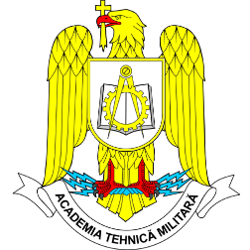
Erasmus code: P PORTO 05
Subject area code: 71, 061
Subject area name: Engineering and Engineering Trades, Communication and Information Technologies
Study cycle: 1st, 2nd,
Number of students / mobility period: 2*12
Number of staff / mobility period: 1/5 days STA
Slovakia
J.Selye University / www.ujs.sk/hu
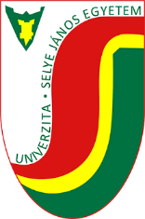
Erasmus code: SK KOMARNO01
Subject area code: 061
Subject area name: Communication and Information Technologies
Study cycle: 1st, 2nd,
Number of students / mobility period: 2*5
Number of staff / mobility period: 1/5 days STA
Slovak University of technology on Bratislava
www.stuba.sk/english.html?page_id=132
Erasmus code: SK BRATISL01
Subject area code: 732
Subject area name: Building and Civil Engineering
Study cycle: 1st, 2nd,3rd
Number of students / mobility period: 3*5
Number of staff / mobility period: 1/5 days STA
Slovak University of Agriculture in Nitra
www.uniag.sk/en/main-page
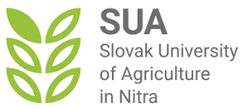
Erasmus code: SK NITRA02
Subject area code: 0721
Subject area name: Food Processing
Study cycle: 1st, 2nd,
Number of students / mobility period: 2*5
Number of staff / mobility period: 2/5 days STA, 1/5 STT
Turkey
Dicle University / www.dicle.edu.tr
Erasmus code: TR DIYARBA01
Subject area code: 07
Subject area name: Engineering
Study cycle: 1st
Number of students / mobility period: 2*5
Number of staff / mobility period: 2/5 days STA
Haliç University / halic.edu.tr/en
Erasmus code: TR ISTANBU15
Subject area code: 071
Subject area name: Engineering and Engineering trade
Study cycle: 1st
Number of students / mobility period: 2*5
Number of staff / mobility period: 2/5 days STA
Yildiz Technical University / yildiz.edu.tr/en
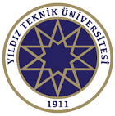
Erasmus code: TR ISTANBU07
Subject area code: 071
Subject area name: Engineering and Engineering trade, Biomedical Engineering
Study cycle: 1st
Number of students / mobility period: 4*5
Number of staff / mobility period: 2/5 days STA
Karabuk University / www.karabuk.edu.tr/en
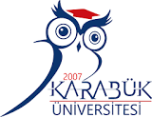
Erasmus code: TR ISTANBU15
Subject area code: 071
Subject area name: Engineering and Engineering trade, Biomedical Engineering
Study cycle: 1st, 2nd
Number of students / mobility period: 2*5, 2*5
Number of staff / mobility period: 2/5 days STA
Altinbaş University
international.altinbas.edu.tr/en
Erasmus code: TR ISTANBU38
Subject area code: 071
Subject area name: Engineering and Engineering trade
Study cycle: 1st, 2nd
Number of students / mobility period: 4*5
Number of staff / mobility period: 2/5 days STA
Firat University
www.firat.edu.tr/en
Erasmus code: TR ELAZIG01
Subject area code: 071
Subject area name: Engineering and Engineering trade, Biomedical Engineering
Study cycle: 1st, 2nd
Number of students / mobility period: 4*5
Number of staff / mobility period: 2/5 days STA
Erciyes University / www.erciyes.edu.tr
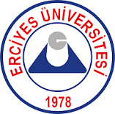
Erasmus code: TR ELAZIG01
Subject area code: 071
Subject area name: Engineering and Engineering trades, Mrchatronics
Study cycle: 1st, 2nd
Number of students / mobility period: 4*5
Number of staff / mobility period: 2/5 days STA
Erzurum Technical University
erzurum.edu.tr/en#gsc.tab=0
Erasmus code: TR ERZURUM02
Subject area code: 732
Subject area name: Building and Civil Engineering
Study cycle: 1st, 2nd
Number of students / mobility period: 4*5
Number of staff / mobility period: 2/5 days STA
Balikesir University / www.balikesir.edu.tr/en
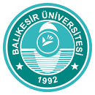
Erasmus code: TR BALIKES01
Subject area code: 071
Subject area name: Engineering and Engineeting trades, Mechatronics
Study cycle: 1st, 2nd
Number of students / mobility period: 4*5
Number of staff / mobility period: 2/5 days STA
Sakarya University of Applied Sciences
www.subu.edu.tr/en
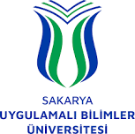
Erasmus code: TR SAKARYA02
Subject area code: 071
Subject area name: Engineering and Engineeting trades, Mechatronics
Study cycle: 1st, 2nd
Number of students / mobility period: 4*5
Number of staff / mobility period: 2/5 days STA
Istanbul Medipol University
www.medipol.edu.tr/en
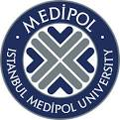
Erasmus code: TR ISTANBU36
Subject area code: 071
Subject area name: Engineering and Engineeting trades, Mechatronics
Study cycle: 1st, 2nd
Number of students / mobility period: 4*5
Number of staff / mobility period: 2/5 days STA
Bulent Ecevit University
en.beun.edu.tr
Erasmus code: TR ZONGULD01
Subject area code: 071
Subject area name: Engineering and Engineeting trades, Biomedical Engineering
Study cycle: 1st, 2nd
Number of students / mobility period: 4*5
Number of staff / mobility period: 2/5 days STA
Izmir Bakircay University / bakircay.edu.tr
Erasmus code: TR IZMIR10
Subject area code: 071, 061
Subject area name: Engineering and Engineeting trades, Biomedical Engineering, Communication and Information Technologies
Study cycle: 1st, 2nd
Number of students / mobility period: 2*5
Number of staff / mobility period: 2/5 days STA

