Uczelnie humanistyczne
Croatia
University of Zagreb / www.unizg.hr/homepage
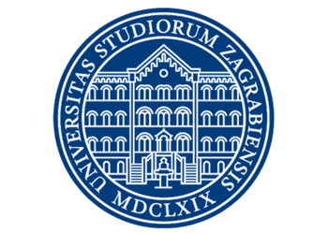
Erasmus code: HR ZAGREB 01
Subject area code: 023
Subject area name: Languages
Study cycle: 1st
Number of students / mobility period: 2*5
Number of staff / mobility period: 1/5 days STA
Czechia
Technická Univerzita V Liberci / www.tul.cz
Subject area code: 01-011
Subject area name: Education
Study cycle: 1st,2nd
Number of students / mobility period: 3*5
Number of staff / mobility period: 1/5 days STA, 1/5days STT

University of Ostrava / www.osu.eu
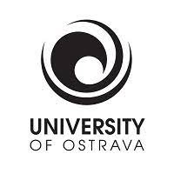
Erasmus code: CZ OSTRAVA01
Subject area code: 01
Subject area name: Education
Study cycle: 1st, 2nd
Number of students / mobility period: 2*5
Number of staff / mobility period: 1/5 days STA, 1/5 days STT

Tomas Bata University in Zlin
UNIVERZITA TOMASE BATI VE ZLINE / www.utb.cz
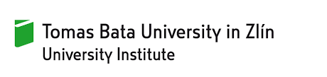
Erasmus code: CZ ZLIN01
Subject area code: 023
Subject area name: Languages
Study cycle: 1st
Number of students / mobility period: 2*5
Number of staff / mobility period: 1/5 days STA

Univerzita Pardubice / www.upce.cz
Erasmus code: CZ PARDUB01
Subject area code: 023
Subject area name: Languages
Study cycle: 1st,2nd
Number of students / mobility period: 2*5
Number of staff / mobility period: 2/5 days STA

Finland
Oulu University of Applied Sciences / www.oamk.fi/en

Erasmus code: SF OULU11
Subject area code: 23
Subject area name: Languages
Study cycle: 1st
Number of students / mobility period: 2*5
Number of staff / mobility period: 2/5 days STA

France
UNIVERSITE BORDEAUX MONTAIGNE
www.u-bordeaux-montaigne.fr/fr/index.html
Erasmus code: F BORDEAU03
Subject area code: 023
Subject area name: Languages
Study cycle: 1st
Number of students / mobility period: 2*5
Number of staff / mobility period: 2/5 days STA

Germany
Heinrich Heine University Dusseldorf / www.hhu.de
Erasmus code: D DUSSELD01
Subject area code: 23
Subject area name: Languages
Study cycle: 1st
Number of students / mobility period: 2*5
Number of staff / mobility period: 2/5 days STA

Hungary
University of Pannonia / eng.uni-pannon.hu
Erasmus code: HU VESZPRE01
Subject area code: 23
Subject area name: Languages
Study cycle: 1st
Number of students / mobility period: 2*5
Number of staff / mobility period: 2/5 days STA

Karoli Gaspar University of Reformed Church in Hungary
english.kre.hu
Erasmus code: HU BUDAPES10
Subject area code: 23
Subject area name: Languages
Study cycle: 1st
Number of students / mobility period: 2*5
Number of staff / mobility period: 2/5 days STA

Latvia
Latvian Academy of Culture / www.lka.edu.lv/en
Erasmus code: LV RIGA08
Subject area code: 23
Subject area name: Languages
Study cycle: 1st, 2nd
Number of students / mobility period: 2*5
Number of staff / mobility period: 2/5 days STA

Lithuania
Vilnius Gediminas Technical University
vilniustech.lt/index.php?lang=2
Erasmus code: LT VILNIUS02
Subject area code: 23
Subject area name: Languages
Study cycle: 1st, 2nd
Number of students / mobility period: 2*5
Number of staff / mobility period: 2/5 days STA

Norway
University of Bergen / www.uib.no/en
Erasmus code: N BERGEN01
Subject area code: 23
Subject area name: Languages
Study cycle: 1st, 2nd
Number of students / mobility period: 2*5
Number of staff / mobility period: 2/5 days STA

Western Norway University of Applied Sciences / www.hvl.no/en
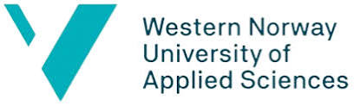
Erasmus code: N BERGEN14
Subject area code: 23
Subject area name: Languages
Study cycle: 1st, 2nd
Number of students / mobility period: 2*5
Number of staff / mobility period: 2/5 days STA

Portugal
Polytechnic Institute of Bragança
portal3.ipb.pt/index.php/en/ipben/home
Erasmus code: P BRAGANC01
Subject area code: 23
Subject area name: Languages
Study cycle: 1st
Number of students / mobility period: 1*5
Number of staff / mobility period: 2/5 days STA

Universidade do Algarve / www.ualg.pt
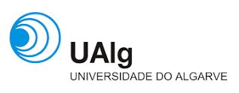
Erasmus code: P FARO02
Subject area code: 23
Subject area name: Languages
Study cycle: 1st
Number of students / mobility period: 1*5
Number of staff / mobility period: 2/5 days STA

Romania
Military Technical Academy of Bucharest / mta.ro
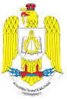
Erasmus code: RO BUCURES02
Subject area code: 23
Subject area name: Languages
Study cycle: 1st
Number of students / mobility period: 1*5
Number of staff / mobility period: 2/5 days STA

University of Craiova / www.ucv.ro/en
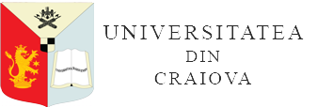
Erasmus code: RO BUCURES02
Subject area code: 23
Subject area name: Languages
Study cycle: 1st
Number of students / mobility period: 1*5
Number of staff / mobility period: 2/5 days STA

Slovakia
J.Selye University / www.ujs.sk/hu
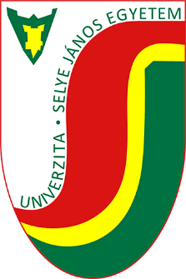
Erasmus code: SK KOMARNO01
Subject area code: 23
Subject area name: Languages
Study cycle: 1st
Number of students / mobility period: 2*5
Number of staff / mobility period: 2/5 days STA

Spain
Universidad de Granada / www.ugr.es
Erasmus code: E GRANADA01
Subject area code: 23
Subject area name: Languages
Study cycle: 1st
Number of students / mobility period: 2*5
Number of staff / mobility period: 2/5 days STA

Universidade de Vigo / www.uvigo.gal
Erasmus code: E VIGO 01
Subject area code: 23
Subject area name: Languages
Study cycle: 1st
Number of students / mobility period: 1*5
Number of staff / mobility period: 2/5 days STA

Universidade de Coruna / udc.es
Erasmus code: E LACORU 01
Subject area code: 23
Subject area name: Languages
Study cycle: 1st
Number of students / mobility period: 4*5
Number of staff / mobility period: 2/5 days STA

Sweden
Hogskolan Dalarna/ www.du.se
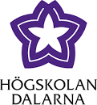
Erasmus code: S FALUN01
Subject area code: 23
Subject area name: Languages
Study cycle: 1st
Number of students / mobility period: 2*5
Number of staff / mobility period: 2/5 days STA

Turkey
Haliç University / halic.edu.tr/en
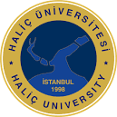
Erasmus code: TR ISTANBU15
Subject area code: 23
Subject area name: Languages
Study cycle: 1st
Number of students / mobility period: 2*5
Number of staff / mobility period: 2/5 days STA

Dokuz Eylul University – Izmir / global.deu.edu.tr
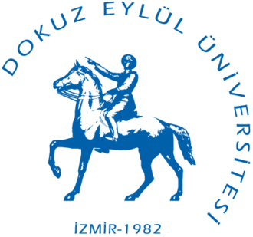
Erasmus code: TR IZMIR01
Subject area code: 23
Subject area name: Languages
Study cycle: 1st
Number of students / mobility period: 2*5
Number of staff / mobility period: 2/5 days STA

Karabuk University / www.karabuk.edu.tr/en
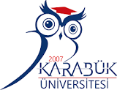
Erasmus code: TR KARABUK01
Subject area code: 23
Subject area name: Languages
Study cycle: 1st
Number of students / mobility period: 4*5
Number of staff / mobility period: 2/5 days STA

Dicle University / www.dicle.edu.tr
Erasmus code: TR DIYARBA01
Subject area code: 23
Subject area name: Languages
Study cycle: 1st, 2nd
Number of students / mobility period: 2*5
Number of staff / mobility period: 2/5 days STA

Firat University / www.firat.edu.tr/en
Erasmus code: TR ELAZIG01
Subject area code: 23
Subject area name: Languages
Study cycle: 1st
Number of students / mobility period: 1*5
Number of staff / mobility period: 2/5 days STA

Ordu University / www.odu.edu.tr
Erasmus code: TR ORDU01
Subject area code: 23
Subject area name: Languages
Study cycle: 1st
Number of students / mobility period: 2*5
Number of staff / mobility period: N/A

