POLITECHNIKA KOSZALIŃSKA
WYDZIAŁ HUMANISTYCZNY
KIERUNEK: FILOLOGIA
SPECJALNOŚĆ: Filologia angielska
[Name and surname]
Nr albumu:
[Thesis title in English]
[Thesis title in Polish]
Praca licencjacka napisana
w Katedrze Filologii
pod kierunkiem [promotora]
_____________________________
(data i podpis promotora)

SUMMARY
Write a summary of your BA thesis in Polish in 200 words (±20 words). Use WH Body to write the content of this section. WH Body is a custom style which uses Times New Roman 12 with 1,25cm indentation. The summary in Polish should be a translation of the summary in English.

Keywords:
STRESZCZENIE
Write a summary of your BA thesis in Polish in 200 words (±20 words). Use WH Body to write the content of this section. WH Body is a custom style which uses Times New Roman 12 with 1,25cm indentation.

Słowa kluczowe:
OŚWIADCZENIE
……………………………………………………………………………………………
Imię i nazwisko studenta
……………………………………………………………………………………………
Nr albumu
Oświadczam, że moja praca pt.: ……………………………………………………………….............................................
……………………………………………………………………………………………
1) została przygotowana przeze mnie samodzielnie*,
2) nie narusza praw autorskich w rozumieniu ustawy z dnia 4 lutego 1994 r. o prawie
autorskim i prawach pokrewnych (j.t. Dz. U. z 2006 r. Nr 90, poz. 631 z późn. zm.)
oraz dóbr osobistych chronionych prawem,
3) nie zawiera danych i informacji, które uzyskałem w sposób niedozwolony,
4) nie była podstawą nadania dyplomu uczelni wyższej lub tytułu zawodowego ani mnie ani innej osobie.
Ponadto oświadczam, że treść pracy przedstawionej przez mnie do obrony, zawarta na
przekazywanym nośniku elektronicznym, jest identyczna z jej wersją drukowaną.

…………………………………….………………………………………………………
Data i podpis studenta

*Uwzględniając merytoryczny wkład promotora (w ramach prowadzonego seminarium dyplomowego

Table of contents
SUMMARY I
STRESZCZENIE II
OŚWIADCZENIE III
Table of contents IV
List of tables V
List of figures VI
Introduction 1
Chapter 1: [Write the title here] 2
1.1. Citing sources 2
1.2. Listing 2
1.3. Text formatting 3
Chapter 2: [Write the title here] 4
2.1. Block quotation 4
2.2. Tables 4
2.2.1. Figures, graphs and images 5
2.2.1.1. Footnotes 6
2.2.2. [Write the title of the subsection here] 6
Conclusion 8
Appendix I 9
References 10

List of tables
Table 1. VOT measurements for Polish (Keating et al.,1981). 4

List of figures
Fig.1.The title page of the Anglo-Saxon Chronicle. 5
Fig.2. Polish vowel phonemes in a vowel quadrilateral (Jassem, 2003, p.106). 6

Introduction
Write an introduction to your BA thesis. The introduction should be 05 - 1 pages long. Use WH Body to write this section.
In order to correctly edit your BA thesis you need to use the styles in-built in this template. You go to Narzędzia główne → Zmień style. On the right hand side you will see a box with the in-built styles. Depending on what part you write, you have to use the appropriate style. You will mostly use WH Body for the text. You have to use WH Chapter summary to write the summary of each chapter. You should use WH Figure title when you write the title of a figure and WH Table title when you write the title of a table. The text inside a table should be written in WH Table text. If you want to add another chapter, you should use WH Chapter for the chapter title. Write the section containing references at the end of the BA thesis using the style Bibliografia. Should you want to add a new section, e.g. 1.4., you have to choose the appropriate WH Heading. It will receive the correct number automatically.
In the subsequent sections you will see how different elements of your thesis should be edited including citing a source, listing, text formatting, block quotation formatting and adding tables, graphs and images.
- [Write the title here]
Write a 4-5 sentence summary of the chapter. Use WH Chapter summary.
  - Citing sources
Whenever you use any information from a different source, you have to include the source of the information. You can cite the source in the following ways. According to Kic-Drgas (2015), the significance of misunderstandings in communication is often undervalued. Harrison was able to use poetry as a means of talking about important social aspects (Klepuszewski, 2011).
  - Listing
This subsection shows how to introduce a list of aspects that you write about. You always have to explain what it is your are going to list. includes the following issues:
- remember to put a comma at the end of each bullet point,
- remember to put a dot at the end of the last bullet point.
You can also use the following formatting:
- if you need two levels in your list then use the following formatting,
- this is the second level of your list,
- remember to put a comma at the end of the last point.
Do not use any other formatting unless you cite from a different source in which different formatting is used.
  - Text formatting
This section describes which features of text may or may not be used. It is not allowed to start sentences with numbers or other symbols than those of the alphabet. You also should not write any text in bold, e.g. literature, or underline any parts of the text, e.g. literature. Use citation marks only when you quote from a different source, e.g. “The connection between language and emotions is more than tentative” (Dixon & Hodalska, 2014, p. 5).

- [Write the title chapter here]
Write a 4-5 sentence summary of the chapter. Use WH Chapter summary.
  - Block quotation
This section shows how to insert a block quotation. If you quote a larger piece of text you should use WH Block quotation as shown below. Remember that each quotation must be followed by a citation in a bracket including name(s), year and page number.
Several studies have shown that L2 learners differ from L2 native speakers in the perception of L2 phonetic contrasts which differ acoustically from a similar contrast in L1. For example, several studies have shown that the phoneme boundaries of individuals who learned English as an L2 occur at different values along a voice onset time (VOT) continuum than those of English native speaker (Flege & Hillenbrand, 1986, p. 508).
  - Tables
This section shows how to include a table in your BA thesis. All tables should be provided with a title using WH Table title. The table title is located above the table. The table is centered. Remember that all tables should be numbered and included in the List of tables. The content of the table is written using WH Table text. Make sure that you always make a reference to the table number in the text before you insert the table itself (e.g. Table 1 presents/shows/demonstrates). If you do not have any tables in your thesis, delete the List of tables.
Table 1. VOT measurements for Polish (Keating et al.,1981).
Sound | Polish
/p/ | 21,5 ms
/t/ | 27,9 ms
/k/ | 52,7 ms
    - Figures, graphs and images
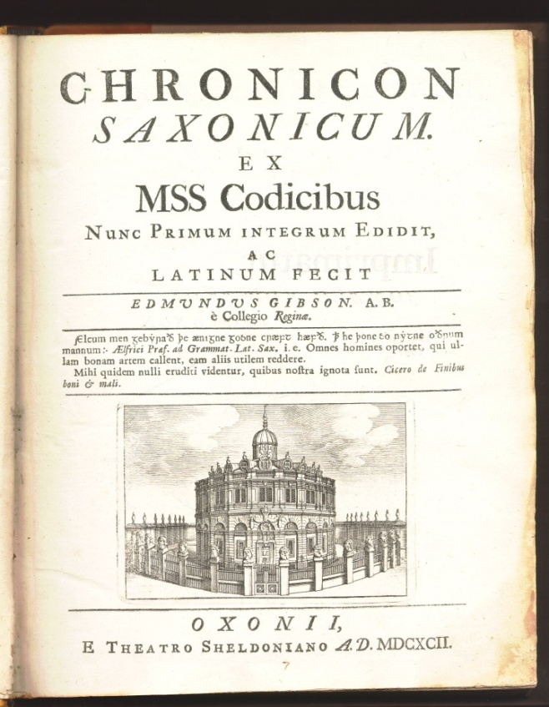
This sections shows how to include a figure, graph or image in your BA thesis. All figures, graphs or images should be provided with a title using WH Figure title. The figure title is located below the figure. The figure is centered. Remember that all figures should be numbered and included in the List of figures. Make sure you always make a reference to the figure number in the text before you insert the figure itself (e.g. Figure 1 presents/shows/demonstrates). If you do not have any figures in your thesis, delete the List of figures.
Fig.1.The title page of the Anglo-Saxon Chronicle.

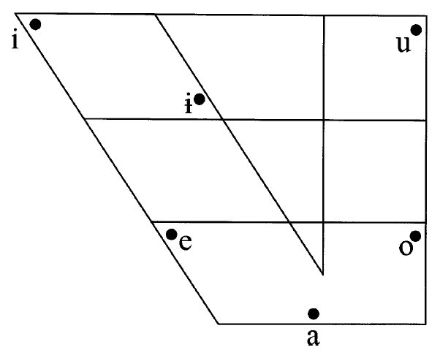
This is a second example of a figure inserted in your thesis. Figure 2 shows the vowel quadrilateral for the Polish language.
Fig.2. Polish vowel phonemes in a vowel quadrilateral (Jassem, 2003, p.106).
      - Footnotes

This part shows how to use footnotes. In the figure title above, there is a footnote. Footnotes are used for two reasons. Firstly, a footnote allows to give the webpage from which your illustration, figure, graph or information were taken if there is no author. Footnote 1 is an example of the first use. Secondly, a footnote allows to provide additional information that would disrupt the flow of the text. Footnote 2 is an example of the second use. Footnotes are numbered automatically. If you decide to delete a footnote, delete the superscript number in the text and not the footnote itself.
This part shows how to use footnotes. In the figure title above, there is a footnote. Footnotes are used for two reasons. Firstly, a footnote allows to give the webpage from which your illustration, figure, graph or information were taken if there is no author. Footnote 1 is an example of the first use. Secondly, a footnote allows to provide additional information that would disrupt the flow of the text. Footnote 2 is an example of the second use. Footnotes are numbered automatically. If you decide to delete a footnote, delete the superscript number in the text and not the footnote itself.

    - [Write the title of the subsection here]
This is the first line of the first paragraph.

Conclusion
Here you should write the conclusion to your BA thesis. It should be 1-2 pages long. In the conclusion you should restate the main aim of the thesis. Moreover, you should provide a short description how you have verified the aim. This should include the hypothesis of your study or analysis. Finally, you should present the most important results of your study or analysis.

Appendix I
You can insert any additional text in the appendix. This includes any survey, questionnaire or large body of text that would disrupt the flow of the body of the chapters. If you have more than one appendix, number them as follows: Appendix I, Appendix II, etc. Appendix title is written using Nagłówek 1. If you do not have any appendices, delete this section.

References
APA style

Retrieved from http://rarebooks.library.nd.edu/exhibits/fructus/old_english/1692anglo.html [accessed on 15.07.2015]
However, it is frequently believed that…
However, it is frequently believed that…

