
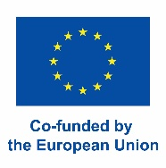
K

OSZALIN UNIVERSITY OF TECHNOLOGY – PL KOSZALI01
PRINCIPLES OF FINANCIAL ALLOCATION FOR THE ERASMUS+ PROGRAM
Granted under contract no. 2025-1-PL01-KA171-HED-000321668 for the period 2025–2028 by the Erasmus+ National Agency and the European Solidarity Corps for the following activities:
SMS – incoming student mobility for study purposes
STA – outgoing and incoming academic staff mobility for teaching purposes
The financial resources under the above contract are subject to strict control and allocation according to the tasks specified in the contract.
- The total amount allocated to the Koszalin University of Technology from the National Agency of the Erasmus+ Program and the European Solidarity Corps for incoming and outgoing STA and incoming SMS mobility is EUR 21422, including EUR 11840 for individual support, EUR 5582 for travel, and EUR 4000 for organizational support.
- Under this contract, the plan includes 2 outgoing teaching staff mobilities (EUR 3364) including EUR 2660 for individual support and EUR 704 for travel. Additionally, 5 incoming teaching staff mobilities are planned (EUR 9663), including EUR 5180 for individual support and EUR 4483 for travel, as well as 1 incoming student for study purposes (EUR 4395), including EUR 4000 for individual support and EUR 395 for travel.
- The amounts indicated above are estimates.
Activities under the STA category:
- Outgoing mobility from Poland to Kosovo: EUR 1639 (1 mobility planned) travel allowance: EUR 390, individual support: EUR 1330
- Outgoing mobility from Poland to Armenia: EUR 1725 (1 mobility planned) travel allowance: EUR 395, individual support: EUR 1330
- Incoming mobility from Cuba to Poland: EUR 2771 (1 mobility planned) travel allowance: EUR 1735, individual support: EUR 1036
- Incoming mobility from Mexico to Poland: EUR 2,771 (1 mobility planned)
travel allowance: EUR 1,735, individual support: EUR 1,036
- Incoming mobility from Azerbaijan to Poland: EUR 1431 (1 mobility planned) travel allowance: EUR 395, individual support: EUR 1036
- Incoming mobility from Kosovo to Poland: EUR 2690 (2 mobilities planned) travel allowance: EUR 618, individual support: EUR 2072
Activities under the SMS category:
- Incoming mobility from Armenia to Poland: EUR 4395 (1 mobility planned) travel allowance: EUR 395, individual support: EUR 4000
- The allocation of the funds awarded for a period of 36 months for financing incoming student mobility for studies (SMS) and outgoing and incoming teaching staff mobility (STA) shall be carried out in accordance with the provisions of the Erasmus+ Programme Guide and the Grant Agreement concluded between Koszalin University of Technology and the Erasmus+ National Agency and the European Solidarity Corps:
    - The grant shall be calculated in accordance with the applicable Erasmus+ KA171 2025 unit costs established by the National Agency (Annex No. 3 to the Grant Agreement).
    - The grant includes: individual support for the mobility period (daily rates for staff and monthly rates for students) and travel days (Table 1), travel support (Table 2).
    - For SMS activities, the basis for calculating the grant is: the period of stay at the receiving institution (Koszalin University of Technology), confirmed in the Letter of Acceptance, travel days, the travel grant determined according to the distance between the sending and receiving institutions. The grant shall be awarded to students selected for Erasmus+ mobility under this agreement for studies at the receiving institution (Koszalin University of Technology) for a period not exceeding one semester. Additional financial support shall be granted to students meeting the criteria of persons with fewer opportunities. In exceptional circumstances, each participant’s case shall be assessed individually.
    - The grant shall be awarded to staff selected for Erasmus+ mobility under this agreement for STA activities at the receiving institution and participants arriving at Koszalin University of Technology from partner universities for STA activities, for a period not exceeding five days.
    - The indicated grant amount is a gross amount
Definition of “persons with fewer opportunities” includes:
- in a difficult financial situation who are entitled to receive a social scholarship referred to in Article 86(1)(1) of the Act of 20 July 2018 – Law on Higher Education and Science (Journal of Laws, as amended) during the semester immediately preceding their departure to the partner institution. As proof, the student shall submit to the International Mobility Office a copy of the decision granting the social scholarship,
- persons with disabilities confirmed by an official disability certificate. Such persons shall submit a valid disability certificate to the International Mobility Office. They may also apply for additional financial support covering actual costs through a separate application submitted to the National Agency. The application must be submitted immediately after the participant has been selected for mobility and no later than five weeks before the mobility period begins,
- persons with children who have not reached the age of eight on the first day of mobility. As proof, a child’s birth certificate shall be submitted to the International Mobility Office,
- persons benefiting from the right to asylum or holding refugee status in Poland. As proof, a declaration confirming asylum or refugee status shall be submitted to the International Mobility Office.
Table 1: Allowance rates for participants
 | Individual support
Incoming Staff from Cuba, Azerbaijan, Kosovo, Mexico to Poland (STA) | €148 per day for mobilities lasting no longer than 14 days, and €103.60 per day thereafter for mobilities exceeding 15 days.
Outgoing Staff from Poland Kosovo, Armenia (STA) | €190 per day for mobilities lasting no longer than 14 days, and €133 per day thereafter for mobilities exceeding 15 days.
Incoming students form Armenia to Poland (SMS) | The monthly rate of allowance for living expenses is €800.

Table 2: Travel allowance based on distance between cities
Distance | Travel using ecological means of transportation “Green Travel” – rate amount | Travel without using ecological means of transportation “Standard Travel”– rate amount
10 km - 99 km: | EUR 56 per participant | EUR 28 per participant
100 km - 499 km: | EUR 285 per participant | EUR 211 per participant
500 km - 1 999 km: | EUR 417 per participant | EUR 309 per participant
2 000 km - 2 999 km: | EUR 535 per participant | EUR 395 per participant
3 000 km - 3 999 km: | EUR 785 per participant | EUR 580 per participant
4 000 km - 7 999 km: | EUR 1,188 per participant | EUR 1,188 per participant
8 000 km or more: | EUR 1,735 per participant | EUR 1,735 per participant
Attention! The amount from the “Green Travel” column and “Standard Travel” column do not add up.
In the cases of travel distance being under or equal to 499km, participants should use low emission means of transportation.
‘Green Travel’ – travel using low-emission/eco-friendly means of transport such as buses, trains, or carpooling – when at least two participants are traveling to the same destination on the same route. ‘Green Travel’ is only applicable when the participant used eco-friendly means of transport the majority for the travel, both ways. ‘Green Travel’ is not automatically granted. The participant must apply to the sending/hosting institution for an increased flat-rate amount for travel under ‘Green Travel.’ The document confirming the fulfilment of the ‘Green Travel’ requirements will be an application/declaration stating that the majority of the travel in both directions will be made using the aforementioned eco-friendly means of transport.
Participants are entitled to receive individual support to cover subsistence costs during travel (travel days) before the start of the mobility period and after its completion:
- for participants receiving a lump-sum contribution for “standard travel”, individual support may be granted for a maximum of 2 travel days;
- for participants receiving a “green travel” lump-sum contribution, individual support may be granted for a maximum of 6 travel days.
The support shall be paid in accordance with the lump-sum rates specified in Table 1. In the case of long-term student mobility, the monthly grant amount shall be divided by 30 days in order to determine the amount payable for each travel day.
- Incoming staff grants will be paid in full upon arrival at Koszalin University of Technology. Outgoing staff grants will be paid in full before departure to host university. For incoming students, 85% of the grant is paid upon arrival at Koszalin University of Technology, and the remaining 15% after the issuance of confirmation of stay by Koszalin University of Technology and completion of the Erasmus+ survey by the student. The settlement of a staff mobility is based on a confirmation of stay from the host institution and an online survey completion.
- Extension (if funds are available) or reduction of mobility duration will be assessed individually.
- If the Koszalin University of Technology has unused funds, additional mobilities from the list of qualified participants at universities in Poland, Cuba, Armenia, Azerbaijan, Kosovo and Mexico will be prioritized, additional recruitment will be announced. The list of nominated participants is sent by the sending universities to Koszalin University of Technology for further implementation of the mobility.
- Organizational support funds will be shared between Koszalin University of Technology and partner universities Universidad Technologica de la Habana Jose Antonio Echeverria (Cuba), National Polytechnic University of Armenia (Armenia), University of Pristina (Kosovo), Universidad Tecnológica de Cancún (Mexico), Azerbaijan Technical University (Azerbaijan), based on bilateral agreements.
- The exact amount of the grant awarded, calculated on the basis of the declared mobility dates and taking into account any additional forms of individual support specified in the tables above, as well as travel support, shall be determined in the agreement concluded between Koszalin University of Technology (KUT) and the mobility participant.
- he start date of the mobility period shall be the first day on which the student is required to be present at the receiving institution (the first day of classes in accordance with the academic calendar of Koszalin University of Technology). The end date of the mobility period shall be the last day on which the student is required to be present at Koszalin University of Technology (defined as the last day of the examination session).
- In the case of participants receiving increased travel support under the “green travel” scheme, the final grant settlement shall include a declaration confirming that the majority of the round-trip journey was completed using low-emission means of transport, together with travel tickets or other supporting documents serving as proof of travel. In the case of the “car-pooling” option, the above-mentioned declaration shall additionally include information confirming that the vehicle was shared with other participants.
- The allocation of funds between institutions is managed by the Koszalin University of Technology Project Coordinator 2025-1-PL01-KA171-HED-0003216 in cooperation with Coordinators at Universidad Technologica de la Habana Jose Antonio Echeverria (Cuba), National Polytechnic University of Armenia (Armenia), University of Pristina (Kosovo), Universidad Tecnológica de Cancún (Mesxico), Azerbaijan Technical University (Azerbaijan).
- Selection of candidates is conducted by sending universities according to their internal recruitment criteria. Koszalin University of Technology does not conduct independent recruitment but allocates funds to participants nominated by partner institutions. The list of nominated participants is sent by the sending universities to Politechnika Koszalińska for further implementation of the mobility.
- The allocation of funds for outgoing mobilities from Koszalin University of Technology is managed by the Erasmus+ University Coordinator and approved by the Vice-Rector for Education.
- The University reserves the right to amend these Rules in the event of receiving new guidelines from the Erasmus+ National Agency and the European Solidarity Corps or where such amendments are required to ensure compliance with national or European Union legislation.
- In matters not regulated by this document, the provisions of the Grant Agreement concluded between the University and the Erasmus+ National Agency and the European Solidarity Corps shall apply.
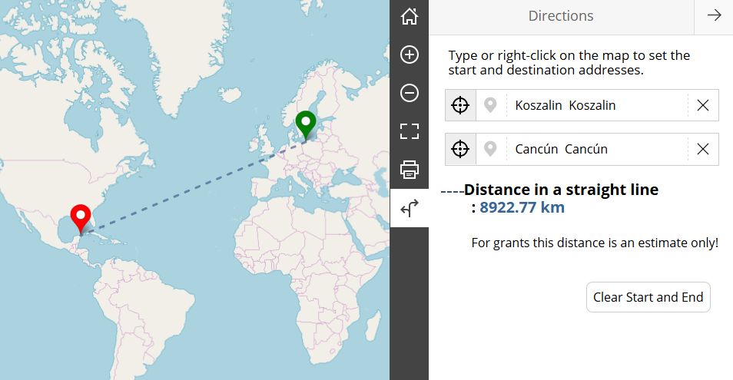

Photo 1. Distance from Koszalin to Cancus (Mexico) according to Erasmus+ Distance Calculator
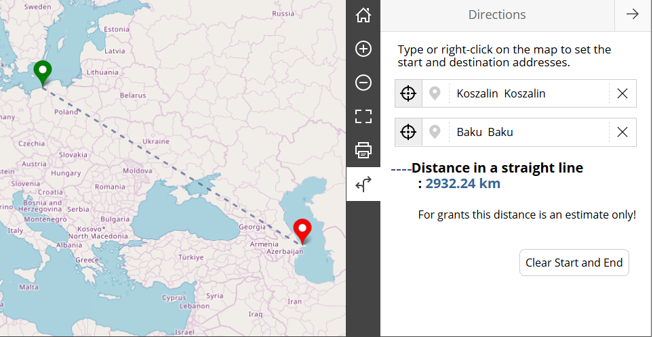

Photo 2. Distance from Koszalin to Baku (Azerbaijan) according to Erasmus+ Distance Calculator
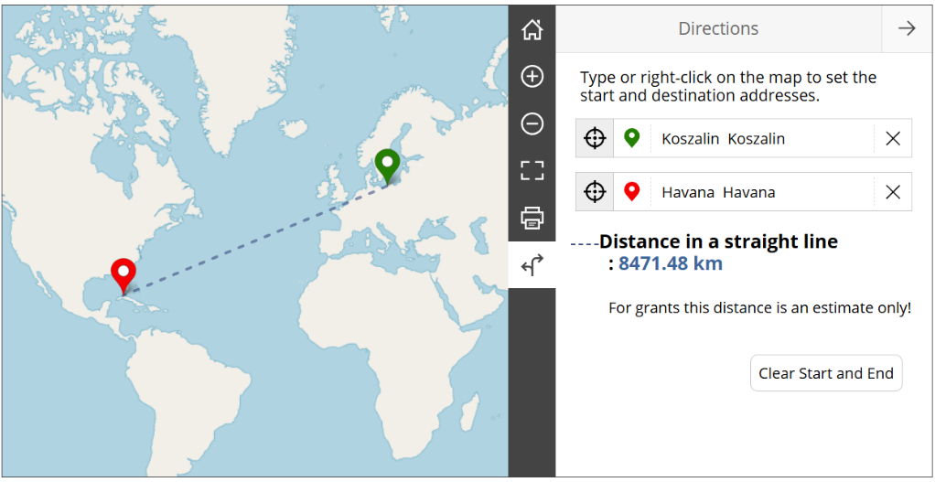

Photo 3. Distance from Koszalin to Havana (Cuba) according to Erasmus+ Distance Calculator

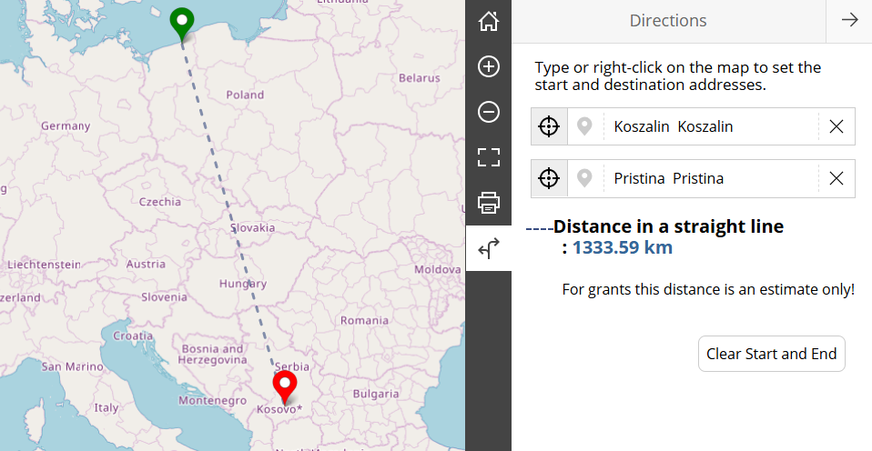

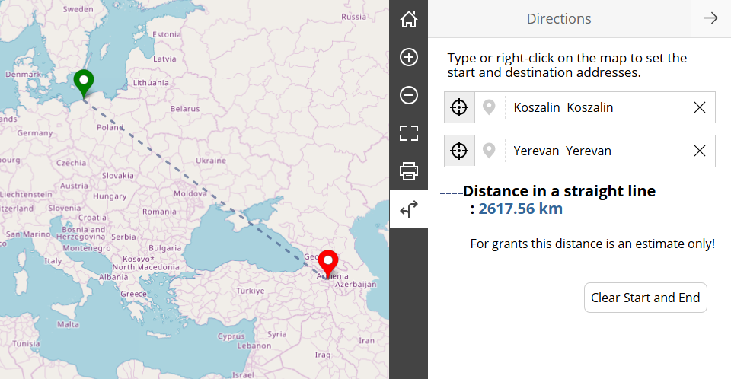
Photo 4. Distance from Koszalin to Pristina (Kosovo) according to Erasmus+ Distance Calculator
Photo 5. Distance from Koszalin to Yerevan (Armenia) according to Erasmus+ Distance Calculator

Erasmus+ Institutional Coordinator Vice-Rector for Education

Erasmus+ KA171 Project Coordinator

Annex No. 3 to the Grant Agreement – Current rates KA171 2025: https://repo.tu.koszalin.pl/bmm/2023/2025/2025-zalacznik-3-stawki-ka131.pdf
The conditions for the award of additional financial support, together with the relevant application form, are available on the website of the Erasmus+ National Agency and the European Solidarity Corps. https://erasmusplus.org.pl/dla-beneficjentow/szkolnictwo-wyzsze/linki/umowy
The travel grant amount, which depends on the distance between the point of departure and the destination, has been determined by the European Commission. By default, the point of departure is understood to be the location where the sending institution is established, while the destination is the location where the receiving organisation is established. To determine the applicable distance band, the beneficiary shall indicate the one-way travel distance, calculated using the online Distance Calculator available on the European Commission’s website: https://erasmus-plus.ec.europa.eu/resources-and-tools/distance-calculator.

